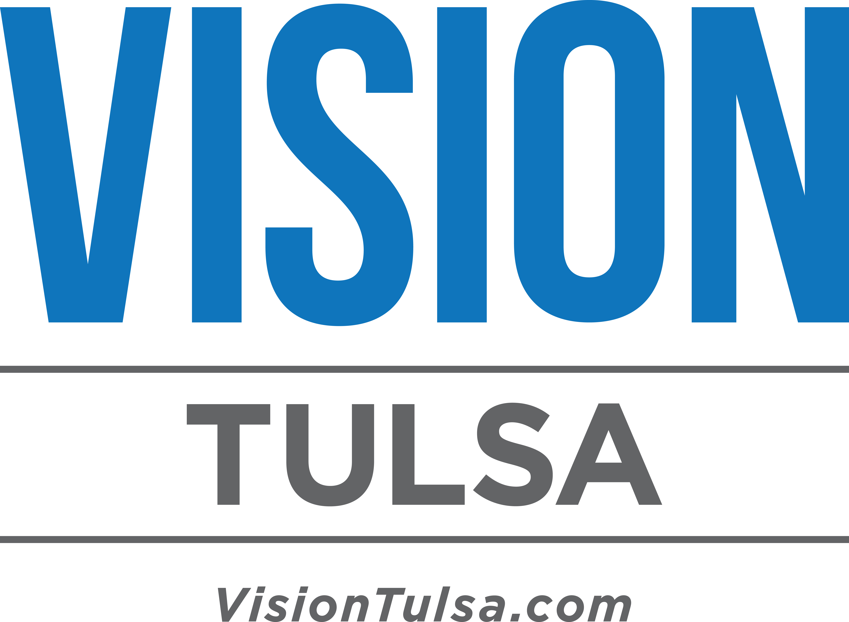

EMPLOYEE COMMUNICATION - REVISED
Sample Newsletter Article or Email

VISION TULSA RENEWAL CAMPAIGN

What you need to know, and how you can help
before the April 5 vote

On April 5, 2016, Tulsa residents have an opportunity to continue moving our community forward—without raising taxes. Vision 2025 generated a tremendous return for Tulsa, igniting downtown’s revitalization and investing in our community’s health, education and job growth. By voting YES on April 5, we can continue growing our community’s economy.

Understanding the Community Need
To determine the best way to move forward with an extension of the Vision funds, Tulsa’s elected officials began exploring options several years ago. After substantial public input events and numerous task force meetings over the years, our leaders crafted a balanced plan that addresses our city's core needs of stronger public safety and ongoing street repair and maintenance, while also investing in key economic priorities including better transit options, developing the Arkansas River corridor, and projects that will create jobs. Read on for a summary of the Vision Tulsa package.

Vision Tulsa – A Summary
The Vision Tulsa renewal package is a balanced plan that addresses our public safety and streets needs while also investing in job opportunities—without raising taxes. Below are additional details about the various components. Voters will have a total of four questions (propositions) on the ballot – three for the City of Tulsa and one for Tulsa County.

Proposition No. 1: Public Safety
- Adds 160 police officers and 65 firefighters.
- Will improve response times for police by having more patrol officers ready to answer calls.
- New street crime units will be deployed to focus on serial crimes like burglary and robbery, using intelligence-led policing to keep neighborhoods safe.
A portion of the public safety funding will be made permanent to assure ongoing investment in our public safety needs.

Proposition No. 2: Streets And Transportation
This portion of the Vision plan will support streets, traffic and public transportation efforts throughout the city by providing the following:
- Two much-needed bus rapid transit routes, which gives two Tulsa communities safe and efficient transportation to jobs, healthcare and groceries. Together, the two BRT lines are within a 10-minute walk of 22% of the city’s residents and 22% of the city’s jobs.
- A new downtown Tulsa loop.
- A new midtown loop.
- Expanded service to include Sunday for 7-day-a-week service.
- Staffing and equipment for street repair and maintenance.
A portion of the streets and transportation funding also will be made permanent to assure ongoing investment in these needs.

Proposition No. 3: Economic Development
This portion of the Vision package is designed to do so much more than just have nice things for Tulsans. It’s intended to create jobs and generate an economic impact return. A few examples of projects are below:
Air National Guard: Provides a local match for the construction of a Mission Training Center at the Tulsa Air National Guard base, a key component in securing operational duties for the next generation aircraft—the F-35—and protecting the base from future base closings.
Education: OSU-Tulsa, Tulsa Community College and Langston University would receive funding to support new facilities for class instruction, student support and job placement through industry partnership. For common education, the Safety First initiative would improve safety at crosswalks for 82 public school sites while also providing critical communication equipment between first responders and administrators at Tulsa Public Schools, Jenks and Union. Finally, funding would also be provided to help recruit and retain teachers for Tulsa Public Schools, Jenks and Union schools.
River Lakes: There is funding for critical infrastructure needs like dam repairs, as well as funding for construction of new dams that will more safely control water flow while creating two river lakes for recreation and also 12 miles of new lake shoreline to be enjoyed. These investments will promote strategic development of areas around the river while preserving Turkey Mountain and other key areas for trails, parkland and recreation. It will be strategic development, not a place for strip malls or big box stores.

County Question
The portion of the Vision Package for Tulsa County will address roads, parks and infrastructure. 700 miles of road and nearly 200 bridges would receive much-needed repairs and maintenance to these thoroughfares that are the backbone of neighborhoods, business and education areas. Funding also would be provided to Tulsa County Parks, which receive 1.5 million visits per year and need repairs and new infrastructure improvements. The County will retrofit and improve existing facilities at Expo Square to enhance our ability to attract quality events. Expo Square generates roughly $300 million in economic impact to the Tulsa area each year. Last, the Tulsa County Courthouse would be improved with better parking and making the building easier to navigate for the thousands of people who use the facility.

For More Information:
- Visit us online at www.VisionTulsa.com
- Follow us on social media:
  - Facebook: www.Facebook.com/VisionTulsaYES
  - Twitter: @VisionTulsaYES
  - Instagram: @VisionTulsaYES

How You Can Help:
If you’d like to volunteer, request a yard sign or schedule a campaign speaker to make a presentation to your group, visit our website at www.VisionTulsa.com, click on the “scroll for more” icon and fill out the appropriate form.

